The premises and the scope of use of tutoring in teaching accounting at a university – the perspective of a student and an academic teacher

ABSTRACT____________________________________________________________
SCIENTIFIC PURPOSE: The purpose of the article is to present the premises and the scope of use of academic tutoring in didactics of subjects from the field of accounting.

THE PROBLEM AND RESEARCH METHODS: The changing economic reality, the growing expectations with regard to professional qualifications, as well as the assumptions of the Higher Education Law Act imply a search for teaching methods that would make the model of university education more appealing, increase its effectiveness and be a response to the growth in educational aspirations of the youth in Poland. The research methods used to achieve this purpose are literature studies and a diagnostic survey with the use of a questionnaire.

REASONING PROCESS: The article first presents the idea science and development tutoring, and then, on the basis of the author's own research, attempts to diagnose the readiness of students and teachers for individualisation of cooperation in teaching subjects from the field of accounting.

RESULTS OF THE SCIENTIFIC ANALYSIS: The results are not generalised beyond the institution where the study was carried out but provide guidelines for other organisations thinking about undertaking activities in the area of personalised education.

CONCLUSIONS, INNOVATIONS, RECOMMENDATIONS: The results of the conducted research indicate that we should not be asking whether tutoring should be used to teach accounting at the academic level, but to what extent and how to move on, taking account of legal, organisational and financial limitations, from theoretical considerations to practical implementations.

KEY WORDS: tutoring, university, academic teacher, accounting.

Introduction
In the definition of the term "studying", many authors emphasise, above all, the need for independence. Studying is defined as a higher form of learning, where the main role is played by intellectual independence. It requires shaping of exceptional mental properties in students, their gradual preparation for unassisted searching, as well as activation of proper motivation and aspiration (Bereźnicki 1998, p. 96). These actions should finally result in a graduate who is able to act and study independently, manage his/her own future and who takes joy in learning. Achievement of such an effect is a result of a complex and time-consuming process but is the necessary condition for building a society learning throughout the whole life, which seems particularly important and valuable in the age of quick technological, economic and social changes (Drumlak 2011, p. 33), as well as in the context of social demand for entrepreneurial attitudes. The key link in this process consists in well-prepared, motivated university teachers, who are open to new solutions (such as tutoring). Personal predispositions, knowledge and social competences in combination with tutoring are an opportunity for the university to achieve a new quality, and, in the further perspective, return to the "true education" and restore the rank of the relation: master – student.
The purpose of the article is to present the premises and opportunities of use of academic tutoring in didactics of subjects from the field of accounting. The research methods used to achieve this purpose are literature studies and a diagnostic survey with the use of a questionnaire, and in the case of formulating conclusions - deduction and synthesis methods.

- Academic tutoring as an individualised teaching method at a university
Kember (1997) distinguishes two broad categories of the concept of teaching: focused on the teacher (and content-oriented) and focused on the student (focused on the learning process). Teachers with an approach focused on the teacher (content-oriented) believe that their role is to provide knowledge, and not to support the learning of students. Research suggests that many academic teachers belong to this category (Biggs 1996; Bennett, Dunne and Carré 2000). However, it seems that, for the broadly understood success of teaching, the most important thing is to establish proper relations between students and teachers. These relations require appropriate interpersonal skills, understood as: promotion of critical thinking, building of motivation and trust, recognition of cultural diversity and individual needs, creation of a climate of empathy and ethical involvement" (Torra et al. 2010).
Tutoring in the Polish reality is a relatively new method of personalised teaching, which seems to be more and more often practised at various levels of education. The interest in this method is undoubtedly a response to the large scale and depersonalisation of the teaching process (Giczela-Pastwa, 2016, p. 187; Wingate 2007), particularly in the area of higher education. Individualisation of the teaching process is an extremely important task (Christ 2013), perceived as the proposed direction of changes (Program rozwoju…, 2015) and an antidote against the decrease in quality and other problems of higher education (Ashcroft 2004). This method assumes personalised approach to the student, while respecting his/her individual needs and predispositions (Baranowska 2014), which, in turn, means concern for his/her integral development, covering not only intellect, but also other spheres.
Tutoring consists in regular meetings (tutorials) of the tutor with the student (tutee), during which the tutees prepare essays (or other tasks) on their own, and then discuss them with the tutor. It is important that tutoring is not focused on improvement in the field of writing as such but puts emphasis on teaching critical thinking and decision-making (Chmura 2013). Depending on the adopted criterion of division, we can distinguish many types of tutoring: peer tutoring, teacher tutoring (Brzezińska and Appelt 2013), development tutoring, science tutoring, art tutoring (Budzyński 2009), and many others. Due to the assumed purpose of the article, it is important to pay attention to the varieties of academic tutoring: science tutoring and development tutoring. We are dealing with a science tutorial when the student "declares that he/she knows what he/she is interested in and what direction of scientific development he/she would like to follow", (Czekierda 2015, p. 25), while development is encountered when the tutee does not know this, but "feels a certain need of development and in a situation when we are directly involved in the personal development of the student", (Czekierda 2015, p. 26). Table 1 compares characteristics of these two kinds of cooperation.
Table 1. Characteristics of science and development tutoring
 | Science tutoring | Development tutoring
Compliance of interests  between the tutor  and the student | There is a compliance of interests between the tutor and the student: e.g. tutor has knowledge of (is interested in) accounting, in the field in which he/she wants to increase his/her competences. The tutor and the student are connected through interests and passions | The ability to explore and lead the student is more important than common interests.
Purpose of tutoring meetings | The purpose of tutoring appears already at the beginning of the relation. The student has a detailed direction of actions: prepare for an examination, learn a specific area of knowledge, prepare an experiment or study. | The purpose of tutoring appears during meetings characterised by a high amount of free, but also orderly exploration.  The student does not specify what he/she is interested in, but he/she feels the need for development.
Area  of tutoring meetings | Search for knowledge and further: search for wisdom. The process is not limited to acquiring information, but is focused on creation, development of independent thinking, search for the truth. | Recognition of the potential, preferences, talents of the student that he/she is unaware of. The process of searching for the form of development and use of this potential.
Main task of the tutor | Determines the work plan, but remains open to new areas and issues, at the same time ensuring that the work moves forward under the main purpose determined at the beginning. | The versatility a tutor should exhibit is supposed to enable traversing the concerned issues. If there is a need for expert knowledge, he/she should lead the student where it is possible to obtain such knowledge.
Level of requirements | The balance between discipline and work consistent with the plan, and free exploration. | Cooperation based on common experiences of the tutor and the student with the student.
Expected effects | Apart from development of knowledge and skills - emphasis put on simultaneous shaping of character. | Discovery and awakening of interests, awareness of talents, but also development of positive features.
Satisfaction from meetings | Meetings should constitute an intellectual pleasure. The role of the tutor is to make a given area of knowledge/development enjoyable, make it give satisfaction and joy. In accordance with the principle stating that passion connected with things we do is the key factor determining success.
Source: Prepared by the author on the basis of (Czekierda 2015, s. 26-27)
The formula of academic tutoring should, by definition, result in development of:
- critical thinking,
- the need for unassisted searching for the truth,
- the art of written and oral expression,
- sensitivity to the value of intellectual work.
The research of Przybylska (2015, p. 159-160) concerning motivation to search for tutoring work indicate three important reasons: the desire to help, self-development of the tutor, experiencing individual relations with the tutee (but also: desire to share passions, desire to make changes for better). At the same time, the very same respondents were convinced that, thanks to tutorials, students will be directed, strengthened, helped in finding themselves in the surrounding reality (apart from the obvious improvement in the field of writing and presentation). Benefits from tutoring may be double-sided. Tutoring for a student may (Brzozowski 2017, p. 299):
- foster self-fulfilment, motivate to constant development;
- enable regular monitoring of results of their own work;
- create the habits of thinking;
- shape the ability to analyse and transform materials;
- build their own stance;
- learn problem solving;
- lead to defending their own opinions;
- effectively use their own resources;
- improve acquisition of wisdom.
The aforementioned skills are priceless, first in effective cooperation of a student with the tutor, and in a long-term perspective - in building proper and ethical social and economic relations.

- Tutoring in teaching accounting at a university – the perspective of students

To meet the requirements of the environment towards quality of practicing of the accountant professions, International Education Standards were prepared (2016), constituting patterns of "good practices" in education regarding accounting. From the point of view of the article, particularly interesting seems to be IES 4. This standard determines the areas of competences and results of education with regard to values, ethics and professional attitudes, which are required from candidates for the accounting professionals at the end of the initial professional development. Tutoring as a method seems to be particularly valuable in shaping the recommended attitudes of self-reliance, curiosity, professional scepticism, and proper objective and rational judgment.
In order to diagnose the current situation and learn the opinions of students about openness to new teaching methods and changes in the teaching process, a study was conducted using survey questionnaire.
The starting point in the process of implementation of tutoring at the University is the transfer of information on tutoring and the training of academic teachers, ready to be tutors and to enrich their teaching offer by this form of cooperation with students. Therefore, it was important to identify the expectations of students and the way they perceive the role of an academic teacher. For this purpose, on the basis of the concept of a good teacher determined by Tokarska (2011, p. 91-92), respondents were asked to indicate the most important features of a good teacher, no more than five; the results are shown on Chart 1.
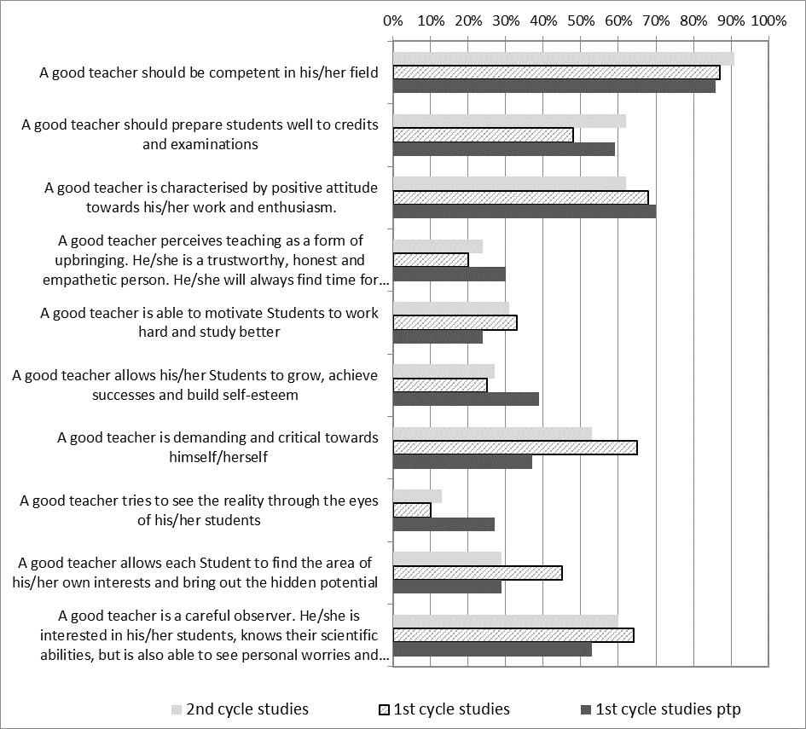
Chart 1. Characteristics of a good academic teacher in the opinion of the examined students

On the basis of answers given by students of 1st and 2nd cycle studies, it can be concluded that a teacher should be, first of all, competent in the field he/she represents and should perform his/her job well and with enthusiasm. It was equally important for the examined students that a teacher was a careful observer, identified possibilities, worries and concerns of students he/she works with, as well as was able to effectively motivate them.
Differences in perception of the tasks of an academic teacher by the students of 1st and 2nd cycle studies can be observed in three characteristics. The 1st cycle students pay less attention to the role of a teacher in preparing for credits and examinations. This can prove their greater self-reliance or can result from the fact that they are not working yet and can devote more time to studying. They also expect from a teacher to be critical and demanding towards himself. They also attach greater weight to the teacher's help in discovering their interests and potential. The 2nd cycle students, who very often combine studies with professional work, appear to be more pragmatic in these matters. Other characteristics of an academic teacher were indicated less frequently, and their importance was similarly perceived by the surveyed students of full-time programmes.
Students of part-time programmes were less concerned with motivating actions of lecturers, identification of possibilities and support of personal problems students, as well as a demanding and critical attitude of the teacher towards his/her own actions. However, their answers more often contained the expectation of support for the development and building self-confidence, as well as perceiving the reality through their eyes. This can result from greater self-reliance and motivation in the process of studying, as well as intensive combination of professional and "student" life.
The confirmation of interests of the examined students used in teaching with the tutoring method were answers to issues included in the question about the education system and the opportunities of scientific and development cooperation with the academic teacher. Answers are presented in Table 2. The questions intentionally did not use the terms "science tutoring" and "development tutoring” but described their main assumptions.

Table 2. Opinions of the examined students on possibilities of scientific and development cooperation with the academic teacher in didactics of subjects from the field of accounting
 | YES |  |  | NO |  |  | I DON’T KNOW
 | II  % | I  % | I ptp % | II  % | I  % | I ptp  % | II  % | I  % | I ptp  %
Are you satisfied with the content of the curriculum (subjects) at the selected specialisation? | 62,2 | 60,9 | 58,2 | 26,7 | 20,3 | 22,8 | 11,1 | 18,8 | 19
If it was possible, would you be interested in an individual educational path? | 51,1 | 42,1 | 41,8 | 22,2 | 40,5 | 34,2 | 26,7 | 17,4 | 24,0
If it was possible, would you be interested in cooperation with the teacher in the field of development? (in order to examine your own potential, preferences, talents, select forms and areas in their development and use) | 84,4 | 65,2 | 79,8 | 2,2 | 11,6 | 10,1 | 13,4 | 23,2 | 10,1
If it was possible, would you be interested in cooperation with the teacher in the field of science? (in order to expand and deepen the curriculum content, conduct joint research and prepare articles) | 66,7 | 55,1 | 70,9 | 11,1 | 21,7 | 20,2 | 22,2 | 23,2 | 8,9
Have you heard about the teaching method of tutoring? | 51,1 | 31,9 | 8,9 | 44,4 | 62,3 | 87,3 | 4,5 | 5,8 | 3,8

Most of the surveyed students of full-time programmes (more than 60%) are satisfied with the content of the curriculum at the selected specialisation. So is not the teaching, but the method of transferring knowledge and working with students that require changes and development. More than 42% of 1st cycle students and 51% of the 2nd cycle students see the need for greater individualisation of teaching, and are interested in an individual educational path.
More than 62% of the surveyed 1st cycle students and 44% of the second cycle students have not heard of teaching using the tutoring method. Bearing the above perspective in mind, answers to questions concerning possibilities of cooperation with an academic teacher indicate a great need for introducing this form of education to the university offer. 65.2% of the surveyed 1st cycle students and 84.4% of the 2nd cycle students are interested in development tutoring and, respectively, 55.1% and 66.7% in science tutoring.
In the answers of students of part-time programmes, attention should be paid to two aspects. More than 34% of the respondents do not see any needs for greater individualisation of teaching but, at the same time, more often than full-time students declare willingness to cooperate with the academic teacher in the field of development (79.8%) and science (70.9%). This may be related to their professional activity and identification of behavioural (Bittern 2011, p. 56-57) and substantive problems in the professional environment. This very large interest in cooperation with the academic teacher is not reflected in familiarity with the tutoring method, which was familiar to nearly 90% of respondents. This means identification of the need for cooperation without knowing the method.
The survey was expanded by an in-depth interview with persons who expressed the desire to share their observations (in addition to filling in surveys earlier). The interview was structured in nature. Subsequent questions concerned e.g. the most important educational experience, an educational experience that influenced the respondent the most, and the person who was connected with this experience.
The diversity of approaches to the concerned issues was astounding. The most broadly interpreted question referred to the significant educational experience. Answers included: experiences associated with a student research circle (which is a typical development and educational experience), a medical rescue course (development of skills and competences outside school), reading books of a specific author (personal development), moving out of the parent's house (treated as an accelerated course of growing up), or the period of starting the studies (as the moment of "educational self-awareness" – understanding what studying means to the student). The common denominator of these experiences was their significant effect on the attitude and perception of oneself. A great surprise for the authors were answers to question about characteristics of a person, which were related mainly with a breakthrough educational experience in the life of the surveyed. Why? Because the answers provided an almost model, "textbook" set of characteristics of a good tutor (see: Table 3).
Table 3. Set of characteristics attributed to a person to whom a breakthrough educational experience was related, on the basis of interviews
"(…) she was able to get me back on track and motivate me to continue fighting to make my dreams come true. (…) she is optimistic, has a sense of humour that is important at difficult times, is stubborn, wants to help everyone who asks for it, is open and honest"
"(…) the trust they placed in me, for the manners they taught me and for everything else that made me who I am today. They were persistent, just, temperate, sometimes strict and rigorous, but also relaxed, interested in my life and education, caring."
"She made sure we were prepared for these contests, she was caring, encouraged us to absolutely go to a university (there were people who did not find it a good solution). She also encouraged us to take risks (…)"
(…) the passion for what he does is a characteristic feature of this person. Other features are: broad knowledge on business or relation topics, persistence, partnership, adhering to his own principles no matter what."
(…) she has developed high immunity to stress in me, the ability to manage time and recognise people I can count on, and she taught me to minimise stress during speeches in front of a big group of people (…)"

3. Tutoring in teaching accounting at a university – the perspective of academic teachers
On the basis of research, analysis of the subject literature, and own observations and experience of the authors, it can be concluded that the starting point in the process of implementation of tutoring during accounting classes is the training of academic teachers within instruments, benefits, but also constraints of this method. Then, a teacher-tutor, familiar with the special character of his/her classes, as well as the possibilities and limitations of students, should introduce specific actions and modifications in the organisation and scenario of classes. In an individualised form, tutoring may be an alternative method for conducting seminars or a student research circle, developing talents and interest of students, helping them find their paths of personal and educational development. It may also be a good way to search for and prepare young scientific staff.
The conducted research indicate that lecturers have a slightly different (from the examined students') way of perceiving the characteristics of a good academic teacher. Like in the case of students, academic teachers were asked to indicate at most five most important objectives of a good teacher. Their opinions concerning their role and attitudes are shaped by the classic approach to studying in the perspective of definitions quoted at the beginning, and emphasising self-reliance of the student. Therefore, none of the lecturers sees the need to identify with the student (0% of answers for the feature defined as perceiving the world through the eyes of the student), and the persistent "leading by the hand" (only 9% of answers for the statement that a good teacher should prepare the student for credits and examinations). According to the surveyed, the high level of competences, positive attitude and enthusiasm, while simultaneously having high demands, shapes the image of a good academic teacher (see: Chart 2).
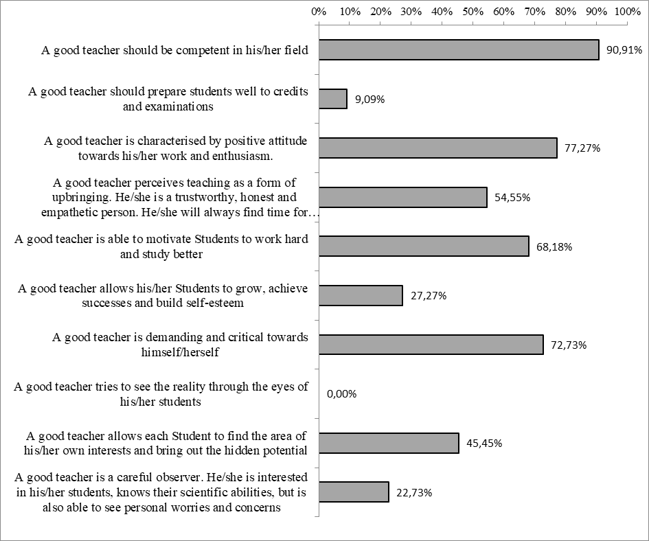
Chart 2. Characteristics of a good academic teacher in the opinion of lecturers

When analysing answers to the subsequent question (see: Chart 3), it can be concluded that the vast majority of the examined scholarly employees notices the need to shift away from mass teaching and towards individualisation of this process (90.91%). Most of them also declare the desire to individualise cooperation with students in the field of science (86.36%) and development (68.18%). Nearly 91% of the examined teachers have heard about tutoring. Such a high percentage of positive answers is certainly a result of numerous publications and conferences concerning teaching methods, as well as the critical assessment and the need for changes in the functioning of higher education in Poland. It is the growing interest of academic teachers in the use of alternative methods of education of students, weariness with the mass character of studies and increasingly numerous participation in didactic programmes and trainings, as well as dissatisfaction of some students with anonymity and depersonalisation of academic education and disappearance of the traditional master – student relationship that may become the real opportunity for implementation of the tutoring method at universities.
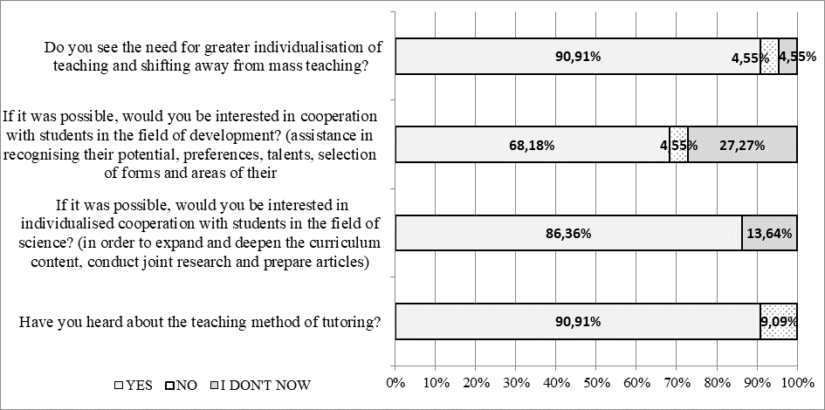
Chart 3. Opinions of the examined lecturers with regard to the possibility of scientific and development cooperation with students in didactics of subjects from the field of accounting

Tutoring is a method of individualised teaching, so it is not possible to cover all students with tutorials. Work with the use of the tutoring method requires the commitment and readiness of students, as well as predispositions to work in the master – student relationship. For this reason, answers to the next question concerning forms of cooperation possible to use in individualisation of teaching of the issues of accounting suggest, first of all, solutions addressed to students who wish to broaden their knowledge in accounting and go beyond the area of obligatory responsibilities.
Teachers conducting classes from the field of accounting see a large positive impact of preparing joint articles (72.73%), conducting joint research (68.18%) and participate in works of student research circles (59.09%) on the achievement of individualisation of the approach in teaching subjects from the area of accounting. Less positive answers were obtained by the division of traditional consultations into didactic and scientific ones, as well as preparation of video presentations, which may result from organisational limitations and academic teachers being strongly burdened by academic and administrative responsibilities. In the leading answers, the worst spot is occupied by an essay, which is a traditional tool of science tutoring. However, there are no grounds to draw conclusions with regard to such a state of affairs. This may be caused the fact that an essay is a relatively unpopular form of realisation of the education process, as well as the low level of tutoring preparation of academic teachers. The functioning of the notion of tutoring in the awareness of teachers does not imply their familiarity with its methods and the way it should be implemented when working with a student.
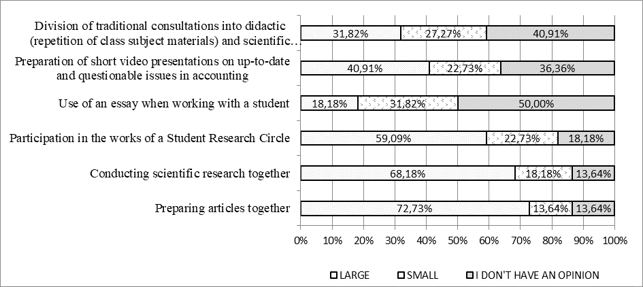
Chart 4. Impact of selected forms of cooperation with students on individualisation of teaching subjects from the field of accounting

The results of the conducted research indicate that we should not be asking whether tutoring should be used to teach accounting at the academic level, but to what extent and in what manner, taking account of legal, organisational and financial limitations, one should move from theoretical considerations to practical implementations. The conducted research is also the basis for discussion on whether and to what extent teaching using the tutoring method may affect the building of entrepreneurial attitudes among the students.

Conclusions
It is sad what was stated by T. Gadacz: "school ceased to be a community of teachers and students, a community where education is implemented – where an educator, as the master traversing the road towards the truth, good and beauty leads students with him and, thanks to them, often himself gets closer to the truth, good and beauty" (Gadacz 2008, pp. 50-51). We can further, in accordance with the existing institutional reality, limit ourselves to transferring the curriculum content and determining the degree of implementation of the learning outcomes contained in syllabuses. However, we may also implement solutions which are not simple, but give the possibility of an authentic meeting and dialogue between the teacher and the student. Participation in such a dialogue, rather than only transfer and reproduction of material, seems to be the essence of a university. Regardless of the theory and idea of teaching that will become the leading one in academic education, it is essential that the graduate is able to independently act and study, as well as manage his/her own future (Drumlak 2011). This ensures proper direction in building a society learning throughout the whole life, postulated in the vision of the Europe of Knowledge (Recommendation of the European Parliament… 2006).
The issues discussed in the article are compatible with the relatively new, although more and more popular in the Polish scientific literature, trend of discussion and reflection over the use of the tutoring method and its suitability at the level of academic education. The use of tutoring in the higher education system is connected with a complex and multistage process requiring systemic, organisational and mental changes, related to the teacher – student (tutor – student) relationship. However, if - at the end of this difficult didactic path - we come across a Person (Student) who has the ability to think critically, analyse and reason, who acts independently and seeks knowledge, who is prepared to express and defend his/her views, who has self-esteem and feels the need to improve, it is the greatest reward to a teacher and the greatest value in the contemporary, complex world.
Tutorial assumes the basic activity of a student – as opposed to classes held in large groups, such as lectures or seminars, during which the student's role is passive. In the education system based only on lectures, the student's task is to absorb the provided knowledge, and not to – as during a tutorial – develop skills necessary to seek the knowledge on his/her own. It is important for a student to be able to communicate his/her thoughts in a clear and interesting manner. As a result, he/she learns not only how to acquire knowledge, but also how to use it and communicate it so that it would reach the recipients. Tutoring is thus the art of communication. It consists in a dialogue and teaches how to communicate one's thoughts. In addition, the tutoring system develops various kinds of independence – in searching for and selecting materials, analysing the subject, synthesising, as well as performing an original interpretation. "The need to defend own theses in a discussion with the tutor makes students using tutoring incomparably more self-confident, independent and entrepreneurial. They are able to effectively use the acquired knowledge. They develop intellectually (as well as socially) extremely quickly" (Pełczyński 2007, p. 33). It seems that these characteristics are extremely important in professions related to accounting.

References:
Ashcroft, K., 2004, The massification of higher education: A comparison of the UK experience and the emerging Ethiopian response, The Ethiopian Journal of Higher Education, Vol. 1, No. 1, pp. 21-40.
Baranowska, A, 2014, Tutoring jako alternatywna metoda pracy z uczniami zdolnymi w szkole, e-mentor, nr 5 (57), ss. 10–19, http://dx.doi.org/10.15219/em57.1136. (dostęp: 31.01.2018).
Bennett, N., Dunne, E., Carré, B., 2000, Skills Development in Higher Education and Employment, Buckingham: The Society for Research into Higher Education and Open University.
Bereźnicki, F., 1998, Przygotowanie pedagogiczne nauczycieli akademickich a samodzielne studiowanie, [w:] Student – nauczyciel akademicki. Relacje interpersonalne, E. Radecki, red., Szczecin.
Biggs, J. B., 1996, Assessing Learning Quality: Reconciling Institutional, Staff, and Educational Demands, Assessment and Evaluation in Higher Education, Vol. 21, ss. 5-15.
Brzezińska, A. I., Appelt, K., 2013. Tutoring nauczycielski – tutoring rówieśniczy: aspekty etyczne, Forum Oświatowe, Vol 25, nr 2 (49), ss.13–29, http://forumoswiatowe.pl/index.php/czasopismo/article/view/39 (dostęp: 30.01.2017)
Brzozowski, T.T., 2017, Tutoring jako alternatywna metoda edukacji, Przedsiębiorczość - Edukacja, Vol. 13, ss. 291-303.
Budzyński, M., 2009, Tutoring szkolny - jak przez dialog rozwijać ucznia i motywować go do nauki, [w:] M. Budzyński, P. Czekierda, J. Traczyński, Z. Zalewski, A. Zembrzuski, red., Tutoring w szkole między teorią a praktyką zmiany edukacyjnej, Towarzystwo Edukacji Otwartej, Wrocław.
Chmura, M., 2013, Tutoring – rozważania nad metodą rozwoju potencjału oraz jej adaptacją na polskich wydziałach prawa (wprowadzenie do dyskusji), [w:] J. Mazurkiewicz, red., Egzamin powinien mieć sens i być sprawiedliwy, Wrocław,www.bibliotekacyfrowa.pl/publication/40555 (dostęp: 30.01.2017).
Christ, M., 2013, Indywidualizacja procesu kształcenia uczniów jako wyzwanie edukacyjne w XXI wieku, Colloquium Wydziału nauk Humanistycznych i Społecznych AMW, 1/2013, ss. 19-36.
Czekierda, P., 2015, Czym jest tutoring?, [w:] P. Czekierda, B. Fingas, M. Szala, red., Tutoring: teoria, praktyka, studia przypadków, Oficyna a Wolters Kluwer business, Warszawa, ss.15-34.
Drumlak, U., 2011, Propozycja zastosowania niekonwencjonalnych metod nauczania rachunkowości w szkołach wyższych, Folia Pomeranae Universitatis Technologiae Stetinensis, Oeconomica, Szczecin, nr 287(63), ss. 31-44.
Gadacz, T., 2008, O ulotności życia, Wydawnictwo Iskry, Warszawa.
Giczela-Pastwa, J., 2016, Cel i relacja w tutoringu akademickim, [w:] Karpińska-Musiał Beata, red., W trosce o jakość w ilości: tutoring oksfordzki w Uniwersytecie Gdańskim, Wydawnictwo Libron-Filip Lohner, ss. 185-194.
Kember, D., 1997, A Reconceptualisation of the Research into University Academics Conceptions of Teaching, Learning and Instruction, Vol.7, No.3, ss. 255–275.
Międzynarodowe Standardy Edukacyjne 1-8 (zaktualizowane), 2016, Karmańska A., red., http://www.skwp.pl/Miedzynarodowe,Standardy,Edukacyjne,1-8,(zaktualizowane),13827.html (dostęp 28.02.2018).
Pełczyński, Z., 2007, Tutoring wart zachodu. Z doświadczeń tutora oksfordzkiego, [w:] B. Kaczarowska red., Tutoring. W poszukiwaniu metody kształcenia liderów, Stowarzyszenie Szkoła Liderów, ss. 31-34.
Program rozwoju szkolnictwa wyższego i nauki na lata 2015–2030, http://www.nauka.gov.pl/aktualnosci-ministerstwo/program-rozwoju-szkolnictwa-wyzszego-i-nauki-nalata-2015‒2030.html [dostęp: 30.01.2017]
Przybylska, L., 2016, Tutoring na Wydziale Oceanografii i Geografii Uniwersytetu Gdańskiego -motywy zaangażowania w nową ofertę dydaktyczną. Annales Universitatis Mariae Curie-Sklodowska, sectio B–Geographia, Geologia, Mineralogia et Petrographia, Vol.70 nr 1, ss. 153-167.
Torra, I., De Corral, I., Pérez, M.J., Triadó, X., Pagès, T., Valderrama, M.I., Márquez, M.D., Sabaté, S., Solà, P., Hernández, C., Sangrà ,A., Guardia, L., Estebanell, M., Patiño, J., González, A.P, Fandos, M., Ruiz, N., Iglesias, M.C., Tena, A., 2010, Identificación de competencias docentes que orienten el desarrollo de planes de formación dirigidos a profesorado universitario, Revista de Docencia Universitaria, Vol.10, No. 2, pp. 21-56.
Wingate, U., 2007, A framework for transition: supporting ‘learning to learn’in higher education, Higher Education Quarterly, Vol. 61, No. 3, pp. 391-405.
Zalecenie Parlamentu Europejskiego i Rady z dnia 18 grudnia 2006 r. w sprawie kompetencji kluczowych w procesie uczenia się przez całe życie, (2006/962/WE), Dziennik Urzędowy Unii Europejskiej.

The survey was conducted among students of the 1st (69 surveys) and 2nd cycle (45 surveys) full-time studies, as well as 1st cycle (79 surveys) part-time studies, who during their studies have been taking classes in accounting. The study conducted by the authors of the article is a continuation of the research: Tutoring jako niekonwencjonalna metoda nauczania w obszarze rachunkowości w szkole wyższej (publication in print).
The survey was conducted among 22 academic employees running classes in the field of accounting.

