Krystyna Buchta
Monika Jakubiak
Małgorzata Skiert
Maria Anna Turosz

Entrepreneurial Competences of the Modern Teacher

Abstract
Education system and the teacher are ascribed a vital role in the knowledge society. Learning and education outcomes greatly depend on the teacher’s qualifications, motivation and personality features. In accordance with the idea of making academic studies more practical, teachers’ entrepreneurial competences gain more and more significance. The role of the teacher in market economy is frequently associated with the organisation of educational process (learning), becoming a natural leader and developer of an attractive educational offer. The paper discusses physical education teachers’ managerial competences. In order to evaluate the level of these competences, surveys were conducted among physical education graduate students majoring in PE teaching. The analysis encompassed several skills recognised as characteristic for entrepreneurial competences of university graduates. It was stipulated that the level of managerial competences acquired in the course of studies deviates considerably from the expected one.

Key words: competences, teachers, entrepreneurship

Introduction
Globalisation and the drive towards improving the level of integrating societies’ education, and upgrading living conditions and facilitating people’s functioning in the changing environment, pose new challenges for universities (Banaszak 2015, p. 94). New expectations regarding universities oblige them to search for answers pertaining to determinants of the modern teachers’ professional success. This, in turn, requires references to the process of educating prospective teachers to be made. Determining the extent to which universities have taken measures in order to prepare graduates for effective functioning in the modern world seems critical. The answers require the issues regarding the development of fundamental relations, creativity and self-development to be considered (Mwasalwiba 2010, pp. 20-47; Kwiatkowski 2015, p. 21).
In order to establish answers regarding the above-mentioned issues, the present study evaluated opinions of the final year, physical education graduate students majoring in PE teaching.
The literature of the subject highlights that the changing world requires both high class experts in technical sciences and those representing knowledge and skills in broadly understood physical culture sciences (Kosiba 2009). Such professionals are expected to facilitate and assist biopsychological development of modern people exposed to numerous individual and social issues (poverty, unemployment, crime, terrorism, etc.) (De Tchorzewski 2006, pp. 63-64). Therefore, higher education must produce a graduate who is stress-resistant, creative and assertive, and who is able to cooperate with others.
In accordance with the idea of making university studies more practical, the demand for teachers’ entrepreneurial competences grows. The role of the teacher in market economy is frequently associated with the organisation of educational process (learning), becoming a natural leader and developer of an attractive educational offer.
The paper discusses entrepreneurial competences of the final year, graduate students majoring in PE teaching. The objective of the study was to identify the level of selected competences facilitating the emergence of prospective teachers’ entrepreneurial attitudes. Respondents’ opinions were related to the significance of these competences in professional work as perceived by the students themselves. For the purpose of the present study, the thesis, which was acknowledged in previous studies (Buchta 2013, p. 100), that the level of the graduates’ entrepreneurial competences deviates considerably from the expected one, was embraced.

Research methods
The literature of the subject categorises competences as general (independent from the course of studies) and factual i.e. those related to university courses and particular knowledge in the particular field of studies (Tuning 2006).
The paper attempts to evaluate the level of selected general competences considered characteristic for entrepreneurial competences exhibited by prospective teachers. Respondents were requested to assess the significance of these competences in their professional work. A four-point scale was applied (1- very low level, 4- very high level). In order to determine possible competence gaps in the analysed variables, a comparative analysis of results was conducted.
Student’s t-test was applied to verify the thesis pertaining to the existence of a competence gap between the level of general competences acquired and their significance in the career. Differences amounting to p<0,05 were assigned statistical significance. In addition, the relationship between the declared level of training as regards entrepreneurship and the level of general competences acquired was analysed. The Pearson correlation method was employed in order to define the degree of dependence between the studied variables.
Empirical data was collected in the framework of surveys conducted among 153 graduate students of the final year PE teaching studies at the University of Physical Education in Warsaw, Biała Podlaska branch, in 2015.

Table 1. Respondents’ structure (data in %; N=153)
Sex | Females | 32,0
Sex | Males | 68,0
Professional status | Employed | 31,4
Professional status | Unemployed | 68,6
Place of residence | City | 49,0
Place of residence | Village | 51,0
Financial standing | Good | 37,3
Financial standing | Average | 57,5
Financial standing | Difficult | 5,2
Grade average | below 3,5 | 21,6
Grade average | <3,5-4,0) | 37,9
Grade average | <4,0-4,5) | 26,1
Grade average | 4,5 and above | 14,4
Type of studies | Full-time | 78,4
Type of studies | Extramural | 21,6
Source: own study.
As far as respondents’ structure is concerned (Tab. 1), 2/3 of them were male. Similarly, 2/3 of respondents were employed.
Moreover, respondents defining their financial standing as average dominated (58%). Students of full-time courses prevailed (78%). Approximately 60% of respondents consisted of students whose grade average did not exceed 4.

Entrepreneurial competences of the modern teacher- formal requirements
Innovative knowledge-based economy requires intellectual capital and applied knowledge generated at universities (Białecki 2010, p. 118). The essence of pro-innovation education lies in the development of individual creative skills and preparation to participating in innovative organisational cultures. Challenges of globalisation determine the long-term direction of education’s development in its practical dimension. Its essence is seen in the skills of independent activity, shaping self-organisation, and resourceful adaptation to changing conditions being imparted. The greatest challenges for education in the 21st century are perceived in innovation and entrepreneurship. Education for innovation is based upon development of skills and key abilities (communicative, social, professional and civil competences) in the process of life-long learning, as well as the provision of opportunities for being creative and active in the educational process (individual and group work, co-responsibility for learning outcomes, co-participation) (Okoń-Horodyńska 2008, pp. 38-39).
Education system and the teacher play a critical role in the knowledge society. Learning and educational outcomes greatly depend on the teacher’s qualifications, motivation and personality features.
The National Qualifications Framework (NQF) define learning outcomes in terms of knowledge, skills and social competences. When studies in medical sciences, health sciences and physical culture are concerned, learning outcomes regarding entrepreneurship assume the graduate will acquire the following (Regulations on NQF 2011):
- knowledge pertaining to general rules for establishing and developing businesses operating in the field associated with the particular study course (M2_W12),
- advanced effective communication and negotiation skills (M2_U01),
- ability to use advanced tools and ITC for data collection (M2_U06),
- advanced skills in management and organisation of recreational, pro-health, sports activities, or those pertaining to motion and movement in work with various social groups (M2_U10),
- language skills in accordance with B2+ of the Common European Framework of Reference for Languages (M2_U15),
- competences related to leadership and entrepreneurship, and team-management skills (M2_K04).
On the other hand, the standards of education for teaching positions (Regulation of the Ministry of Science and Higher Education 2012) feature regulations referring to entrepreneurship in mere two instances: as regards teamwork (skills of organisation and cooperation) and regarding ICT.

Entrepreneurial competences- respondents’ self-assessment
Results of analyses conducted on the basis of empirical data illustrate the above mentioned issues. The study attempted to identify the level of selected general competences facilitating the emergence of entrepreneurial attitudes of prospective teachers and to assess the significance of these competences in the teachers’ careers. The greatest significance among the analysed competences acquired in the course of studies was ascribed to: planning skills, general profession-related knowledge, and independent work (average scores above 3,0 in 1-4 scale; 4 max.). Therefore, it can be stated that these competences constitute assets of physical education studies’ graduates. The lowest scores were noted as regards analysis and synthesis, workgroup management, and development of new ideas (creativity).
The level of competences was compared with the level of their significance perceived by respondents themselves. Results of the analysis indicated considerable discrepancies (Fig. 1). In merely three out of eighteen cases, the level of competences acquired did not exhibit statistically significant differences when compared with the importance of the competences. The remaining indicated a large competence gap (the significance of the particular skill was considerably larger than the level it was acquired).

Figure 1. The level of selected competences as perceived by respondents (score averages; 1-4 scale; 4 max.).
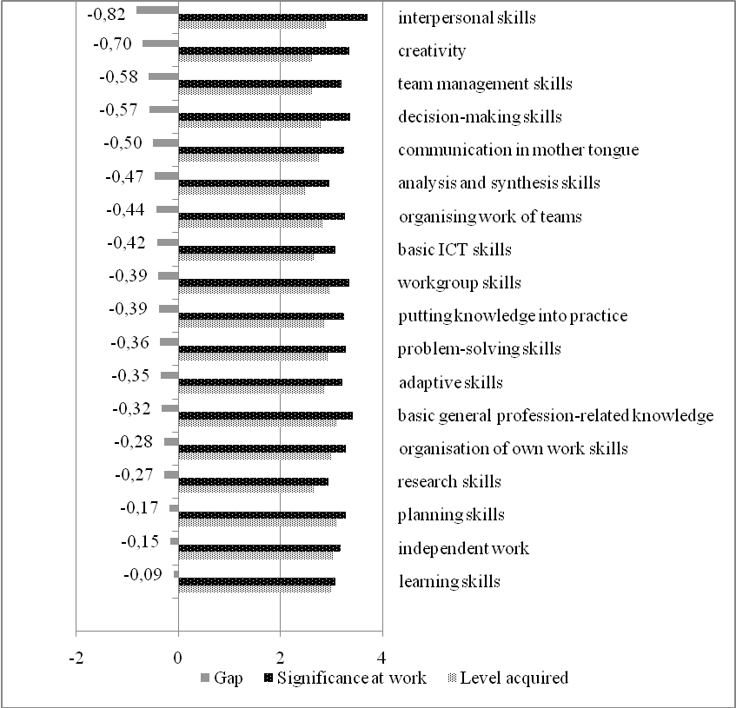
Source: own study.

The greatest discrepancies were observed in the assessment of interpersonal skills (significance at work: 3,7 vs. level acquired: 2,9). Insufficient interpersonal skills may inhibit effective functioning in various social contexts. Teachers require interpersonal skills in order to cooperate and communicate well, both with the students and fellow teachers alike (e.g. in the framework of workgroups). The present study revealed deficits of interpersonal skills as regards team management and cooperation in workgroups.
Creativity constitutes a vital element of entrepreneurship. It is manifested in the readiness to undertake innovative actions. Assuming that the main task of the modern school is the development of creative thinking, such attitude must also become teachers’ priority. Each teacher, as an author, researcher and participant in educational changes, becomes a medium and propagator of novel ideas. Innovation in the teacher’s profession is critical in education and may revolve around development of teaching content or methods. The fact that, following the method of modelling, teachers’ creative attitude facilitates the development of such skills in their students, seems significant (Sitarska 2010, p. 51). Respondents appreciated the value of this aspect in their prospective careers. However, the level of competences they possessed in this respect was assessed much lower (3,3 vs. 2,6).
In the era of information society, graduates’ ICT skills gain significance (Kosiba 2009, p. 266). The teacher ought to possess basic ICT skills and be able to apply these skilfully and critically in education. When assessing respondents’ answers, a considerable competence gap was observed in this respect (3,1 vs. 2,7). Modern technologies, including multimedia, may assist decision-making processes and facilitate access to crucial data among others. As previously, the study revealed a gap between the level of the acquired competences and their declared significance in the teacher’s profession (3,4 vs. 2,8).
The fewest discrepancies pertained to learning, planning, and independent work (scored approx. 3,0 in 1-4 scale). Therefore, the claim that university studies prepared graduates to take the position of a teacher well in this area, is justified.

The level of entrepreneurial competences and their determinants
The extent of knowledge and skills as regards operating a business is indicative of the level of students’ entrepreneurial skills. However, respondents assessed their knowledge in this area as insufficient (average score: 2,74) and only every fifth declared the level as high.
Such findings inclined authors to conduct an in-depth analysis of determinants of respondents’ entrepreneurial competences. The relationship between the general competences acquired and students’ declared level of entrepreneurial competences was considered. A series of correlations (Pearson’s statistics) was calculated to determine the relationship. Figure 2 presents only those values of correlations exhibiting statistical significance.

Figure 2. Pearson’s correlation coefficients- entrepreneurial competences vs. respondents’ general competences (statistically significant differences; p<0,05)
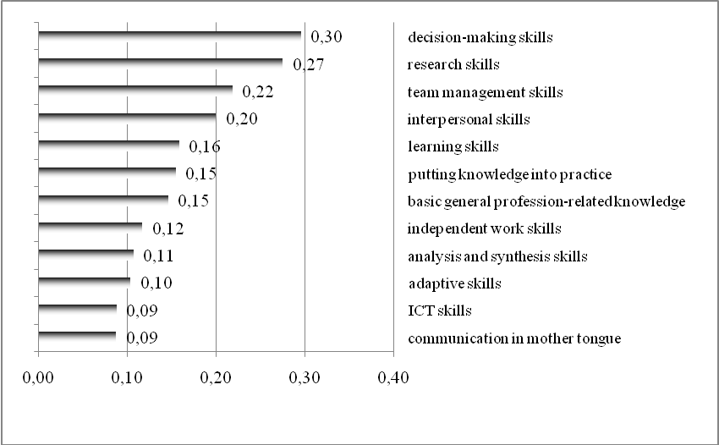
Source: own study.

The analysis of correlation coefficients revealed the strongest relation with the endogenous variable (the general level of entrepreneurial competences) of skills in this respect: decision-making, research, team management, interpersonal skills. The level of these skills was positively correlated with the general level of students’ entrepreneurial competences (in their own assessment).
When establishing answers to the issue of the prospective teacher’s entrepreneurial competences, the analysis of results pertaining to experiences in this area was crucial.

Figure 3. Forms of respondents’ activities (data in %)
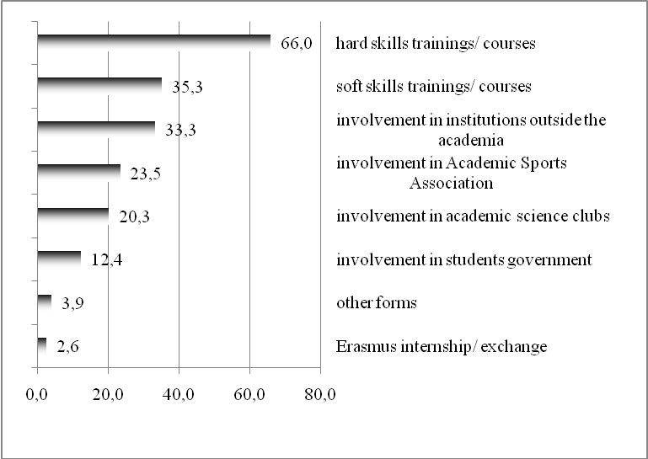
Source: own study.

The analysis encompassed forms of activity undertaken by students in their studies. Results indicated that, most frequently, activities encompassed participation in courses and trainings on hard, career-related competences (almost 2/3 of respondents; Fig. 3). Far fewer of them declared completion of courses on soft competences (approx. 35%). Moreover, every third respondent was a member of social institutions, every fourth was involved in the Academic Sports Association, and every fifth in academic science clubs.
In the global world, the ability to communicate, including communication in foreign languages, gains importance. When evaluating these skills, their relatively low level was revealed. More than half of respondents cannot communicate sufficiently enough in German and Russian, and merely every fifth declared proficiency in English (Fig. 4).

Figure 4. Linguistic proficiency as assessed by respondents (data in %; N=153)

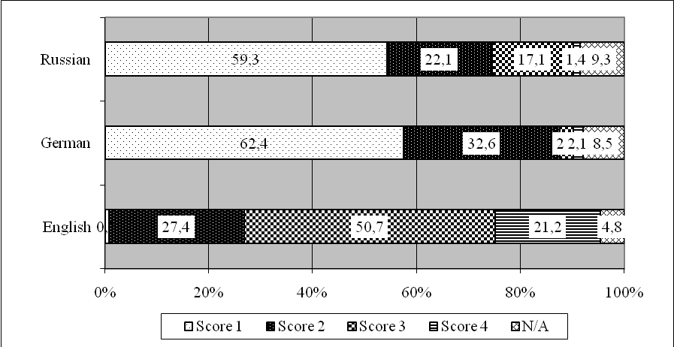
Source: own study.

Summary and conclusions
The issue of the present study pertains to competences of students preparing to enter the teacher’s profession. Changes emerging in economy and labour market generated demand for an educated, linguistically and technologically proficient, dynamic, resourceful people capable of caring for their own personal development. Creativity has become a desired characteristic in any area of human activity, especially as far as teachers and education are concerned. A creative teacher sets an example and stimulates their students’ creativity. This is due to the fact that imitation is a crucial element of attitude shaping (Sitarska 2010, p. 51). In case of PE teachers, creativity and innovation may be applied in education. The literature of the subject highlights that attractive sports and recreation offers coupled with teachers’ creative activities may counter the emerging aversion towards physical activity, and spreading violence and pathologies among the youth (Grabowski 2009, p. 242).
Research results indicate insufficient training of PE studies’ graduates towards such activity. Creativity was revealed to be the respondents’ handicap and ranked a mere 16 out of 18 among the competences acquired. Meanwhile, its significance in the profession ranked 4. Consequently, a verification of curricula and educational methodology of prospective teachers’ education seems critical. When shaping creative attitudes, universities may make use of internships, skills trainings, seminars, conferences, international scholarships or sessions with business practitioners. Creative teaching is also associated with the issue of teaching content and teaching methodology per se. Entrepreneurial teaching requires active methods to be applied, especially activating methods (Wróblewska 2012; Herda-Płonka 2013, pp. 55-56; Wach 2014, p. 16; Rezner 2015). In addition, students need to be motivated towards independent work, making inquiries, solving problems and a greater responsibility for their own development (Sitarska 2010, p. 50).
When the low level of respondents’ entrepreneurial competences is considered (measured by the extent of knowledge pertaining to running a business), intensification of activities and development of conditions favouring popularisation of entrepreneurship among students of physical education, seem vital. Free-market economy requires graduates of such studies to possess typically managerial competences: leadership, motivating students towards physical activity, developing attractive sports and recreation offer, organising such activities, securing financing for these, and effective functioning in local-government and national administrations (Dziubiński 2000, s. 57-68; Ważny 2002, pp. 85-93). Moreover, sufficient knowledge and skills facilitating self-employment may become an alternative for the decreasing demand for teachers of physical education (Jaworski 2002, pp. 20-23).
In conclusion, the study verified the thesis on the insufficient training of students of the selected courses as regards entrepreneurship. The fact that the level of acquired competences (those facilitating the development of entrepreneurial attitudes) considerably diverges from the expected level of these competences was acknowledged. Research results justify the formulation of the following specific conclusions:
- The following constitute strengths as regards acquired general competences: planning, basic general profession-related knowledge, and independent work skills. On the other hand, graduates’ handicaps include: analysis and synthesis, workgroup management, creativity. These skills ought to be developed with the use of active methods of teaching;
- Statistically significant differences between the level of general competences acquired and their significance in the prospective profession were revealed. The greatest differences pertained to interpersonal and creative competences;
- The analysis of correlation coefficients indicated the existence of a positive relationship between the general level of entrepreneurial competences and students’ level of the majority of general skills which were evaluated. The strongest relationship was observed in case of decision-making skills, research, and team management. The development of these facilitates shaping respondents’ entrepreneurial competences;
- Respondents declared involvement in various forms of activities conducted in the course of studies. Majority of these pertained to the development of hard, profession-related competences. Development of soft skills, which constitute a vital characteristic of an entrepreneurial individual, attracted less interest. Therefore, encouraging young people to undertake such activities in the course of their studies seems worthwhile.

References:

Banaszak, S., 2015. Managerial Education: Genesis and Importance in Modern Societies. Studies in Education, no. 35, pp. 85-99.

Białecki, I., 2010. Introduction. Two Trends in Educational Policy? Science and Higher Education, Vol. 35, no. 1-2, pp. 117-124.

Buchta, K., 2013. The Study and Evaluation of the Quality of Education at Physical Education Studies of Selected Universities of Physical Education. Monographs and Studies no. 20, Biała Podlaska: AWF.

Dziubiński, Z., 2000. Trends in Changes of University Physical Education Occurring 10 Years After the Transformation. Scientific Review of Physical and Health Education of the Universty of Rzeszów, no. 1-2, pp. 57-68.

Grabowski, H., 2009. Physical Education Studies Now and Before., Scientific Papers of the University of Physical Education in Wrocław, no. 28, pp. 239-242.

Herda-Płonka, K., 2013. The Role of the Academic Teacher in Stimulating Students’ Development, Education in the Humanities, Vol. 28, no. 1, pp. 53-57.

Jaworski, Z., 2002. Development of Physical Education Studies vs. Graduates’ Employability in Education Sector, Physical and Health Education, no. 5, pp. 20-23.

Kosiba, G., 2009. Institutional Forms of Professional Development of Physical Education Teachers, Scientific Papers of the University of Physical Education in Wrocław, no. 28, pp. 263-268.

Kwiatkowski, S.T., 2015. Successful Teacher’s Career in Light of Familiarity With Individual Differences, Pedagogical Movement, no. 1, pp. 19-34.

Mwasalwiba, E.S., 2010. Entrepreneurship education: a review of its objectives, teaching methods, and impact indicators, Education + Training, Vol. 52, no. 1, pp. 20-47.

Okoń-Horodyńska, E., 2008. Education for Innovation. Are Only the Selected Few Bound for Success in Innovation?, Science and Higher Education, Vol. 38, no. 1, pp. 34-54.

Rezner, A., 2015. A Comprehensive Education Model by Means of a Project Implemented at Polish Universities- a Proposition of Implementation, Pedagogical Movement, no. 2, pp. 99-107.

Sitarska, B., 2010. Creativity of Students and Academic Teachers. W: B. Sitarska, K. Jankowski, R. Droba, edit. Higher Education vs. Labour Market. Siedlce: Wydawnictwo Akademii Podlaskiej, pp. 39-55.

De Tchorzewski, A.M., 2006. A Dispute or Dialog on Higher Education, Studies in Humanities at the University of Physical Education in Krakow, no. 6, pp. 61-69.

Tuning. 2006. Harmonisation of Educational Structures in Europe. Contribution of Universities to the Bologna Process. Education System Development Foundation. National Agency of „Life-long Learning” Program.

Wach, K., 2014. Education for Entrepreneurship: Between Entrepreneurial Pedagogy and Economic and Business Education, Horizons of Education, Vol. 13, no. 28, pp. 11-32.

Ważny, Z., 2002. Education of Personnel vs. Requirements of Modern Sports, Professional Sport, no. 11-12, pp. 85-93.

Wróblewska, W., 2012. Teaching Methods in Light of the Outcomes Defined in the National Qualifications Framework for Higher Education, E-Mentor, Vol. 43, no. 1. <http://e-mentor.edu.pl/artykul/index/numer/43/id/897> (access: 12.12. 2015)..

PhD, Józef Piłsudski University of Physical Education in Warsaw, Biała Podlaska branch, Institute of Marketing and Statistics; ul. Akademicka 2, 21-500 Biała Podlaska (contribution to the study: study conception and design, statistical analyses, text compilation).
PhD, Maria Curie Skłodowska University in Lublin, Faculty of Economics, Institute of Management; Pl. M. Curie-Skłodowskiej 5, 20-031 Lublin (contribution to the study: study conception and design, results’ interpretation, review of literature).
PhD, Józef Piłsudski University of Physical Education in Warsaw, Biała Podlaska branch, Institute of Marketing and Statistics; ul. Akademicka 2, 21-500 Biała Podlaska (contribution to the study: empirical studies, review of literature).
PhD, Józef Piłsudski University of Physical Education in Warsaw, Biała Podlaska branch, Institute of Psychology; ul. Akademicka 2, 21-500 Biała Podlaska (contribution to the study: empirical studies).
The study was conducted in the framework of DS.117 statutory research project financed by the Ministry of Science and Higher Education.
As a result of public consultations with graduates, employers and faculty members (“Tuning” project), general competences became considered as key when university graduates’ employability is concerned.
This encompassed skills such as planning, individual work, and learning.

